# PROBLEM 1

**Task 0:**

My First Computer Program Creating a New Project

It’s time to start! Go ahead and open up Visual Studio from the desktop or start menu.

When you create an app in Visual Studio, you first create a project and a solution. For this example, you’ll create a Windows console application.

* Create a project by pointing to **New** on the **File** menu, and then clicking **Project**.

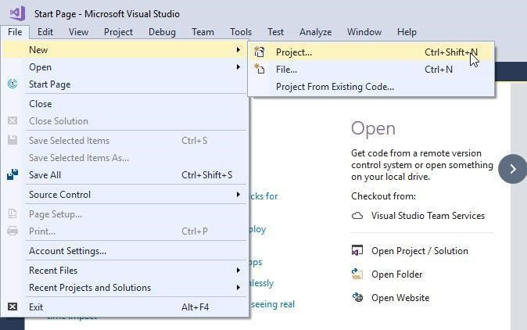

* In the **Visual C++** project types pane, click **Win32**, and then click **Win32 Console Application**.

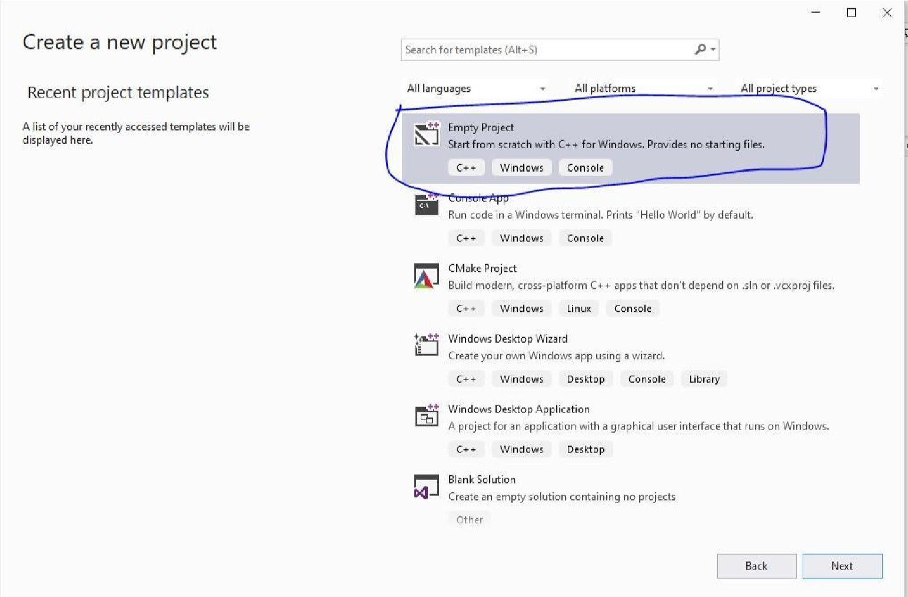

* Type a name for the project.

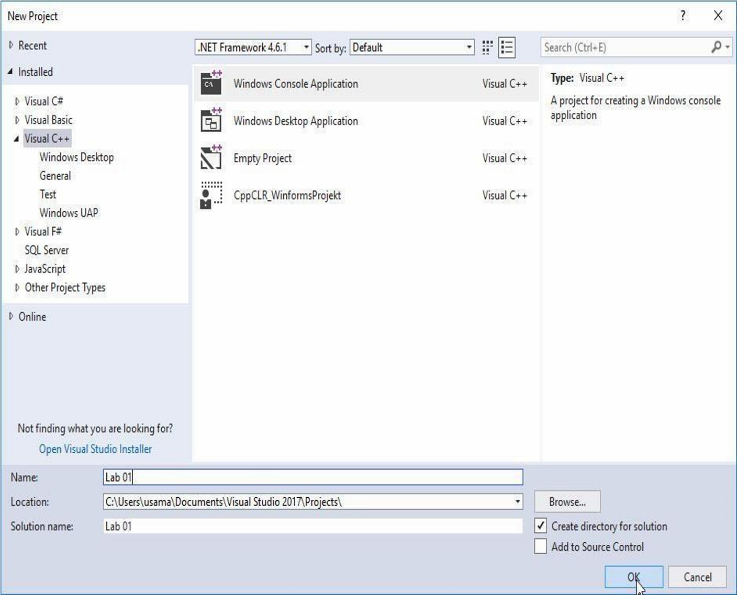

* By default, the solution that contains the project has the same name as the project, but you can type a different name. You can also type a different location for the project.
* Click **OK** to create the project.
* If **Solution Explorer** is not displayed, on the **View** menu, click **Solution Explorer**.

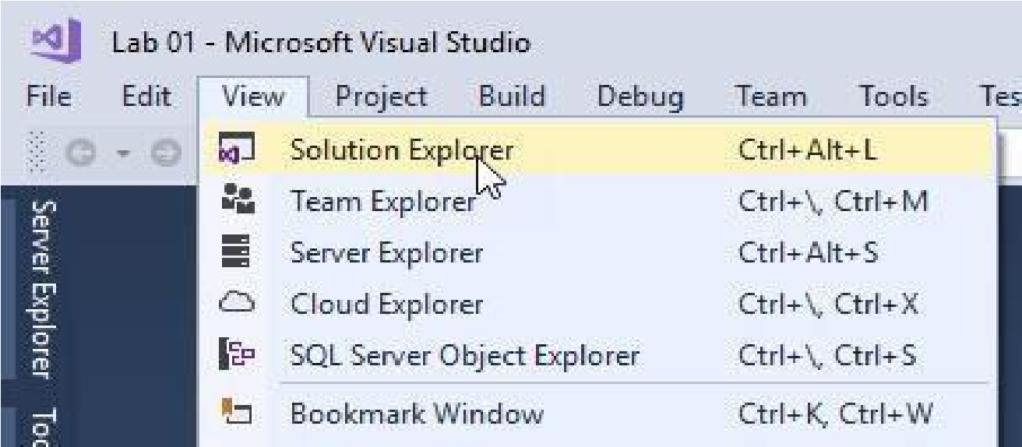

* Add a new source file to the project, as follows.
  + In **Solution Explorer**, right-click the **Source Files** folder, point to **Add**, and then click **New Item**.

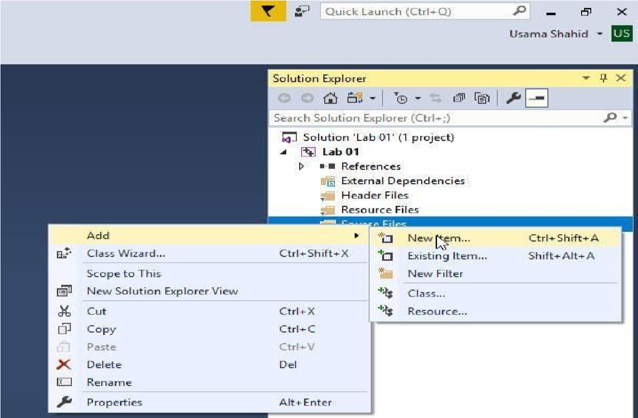

* + In the **Visual C++** node, click **C++ File (.cpp)**, type a name for the file, and then click **Add**.

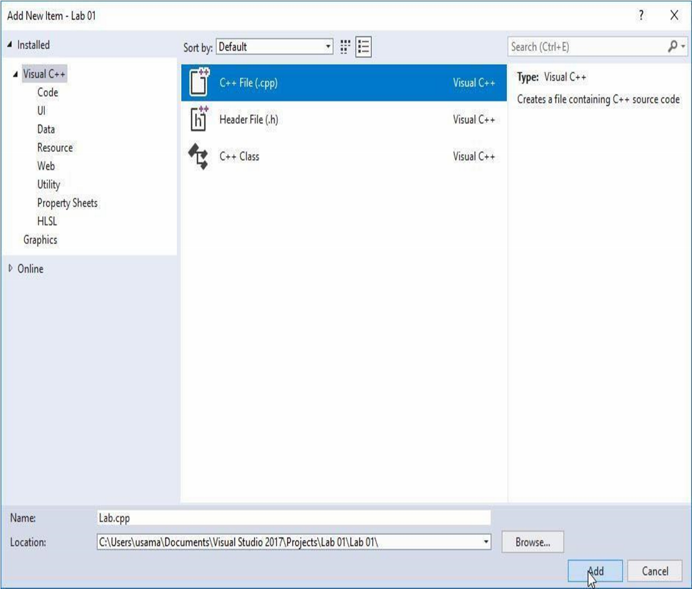

* The **.cpp** file appears in the Source Files folder in **Solution Explorer**, and the file is opened in the Visual Studio editor. • In the file in the editor, type a valid C++ program.

**Task 1:**

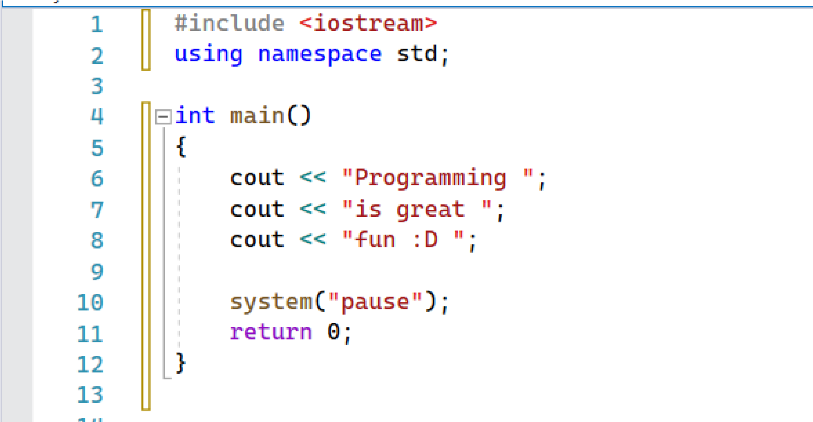

* Write the above code in the file in the editor.
* Compile the code and observe the program output.
* **Task 2:**

Write a C++ program to print **“Hello!! Welcome to the world of programming”** on the console.

* **Task 3:**

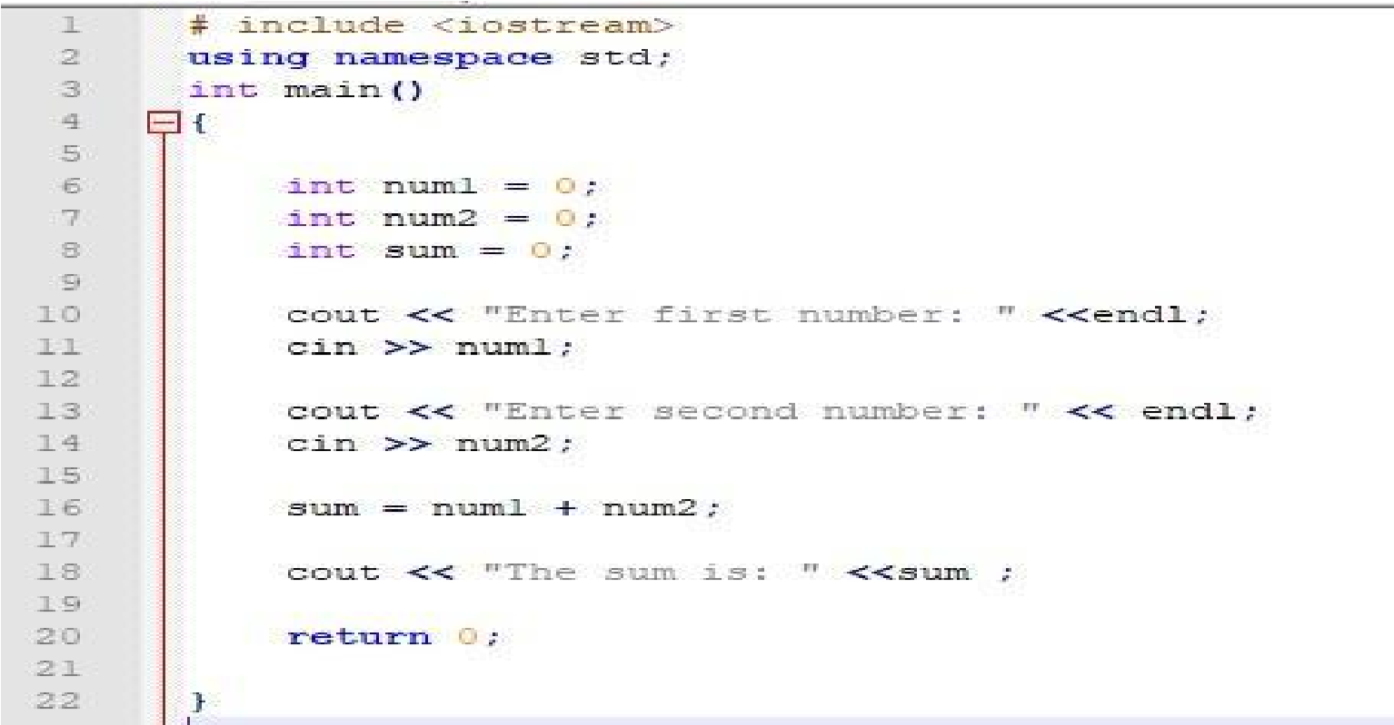

* + Write the above code in the file in the editor
  + Compile the code and observe the program output.

**Task 4:**

* + Write the above code in the file in the editor.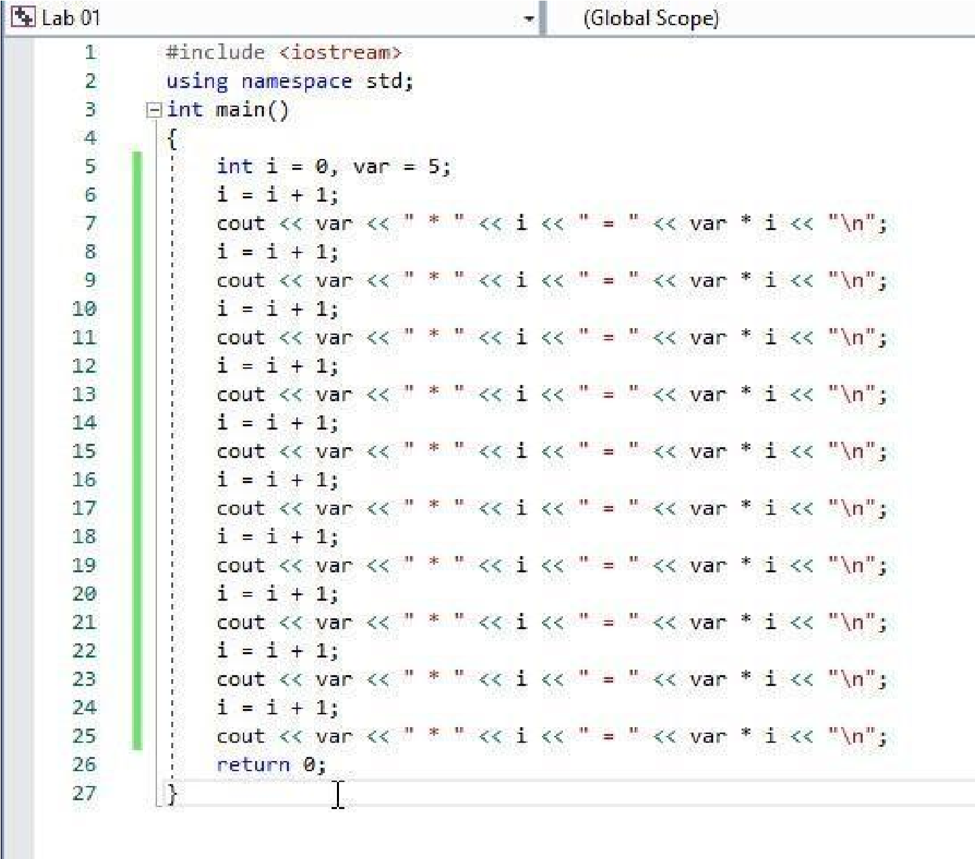
  + Compile the code and observe the program output.
  + Change the above code to print the table 10 and 3

# PROBLEM 2

Write a program which output “Hello World” on console

# Problem 3

Write a program in which reads 3 numbers from the user and display their sum and average.